* **Use Case Diagram:-**
* Use cases represent system functionality from the user’s perspective.
* Use Case diagrams describe who will use the system and in what ways the user expects to interact with the system.
* Use Case diagrams represent the interactions between use cases and actors.
* Use Case diagram represents the interactions between system, external systems, and users.

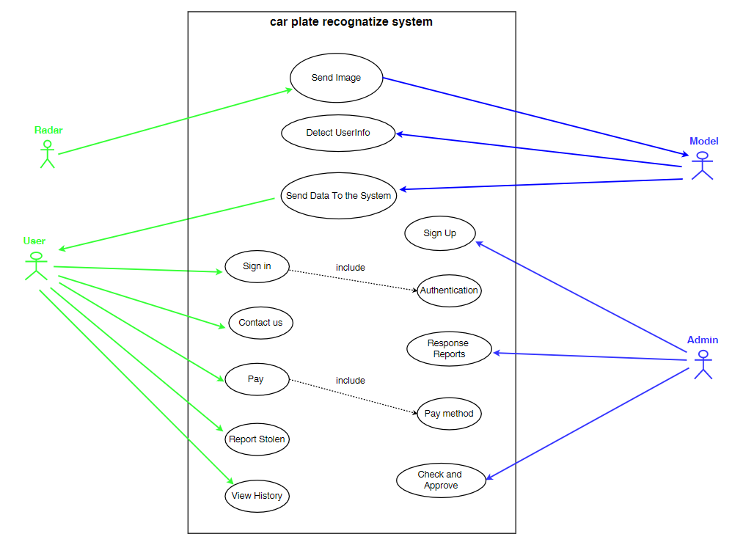

* **Use Case Scenario:-**
* A use case Scenario represents the sequence of events along with other information that relates to this use case.
* A typical use case specification template includes the following information:

- Primary Actor

- Secondary Actor (if exist)

- include use case (if exist)

- Purpose

- Pre and Post condition

|  |  |  |  |  |  |  |  |  |  |  |  |  |  |  |  |  |  |  |  |  |  |  |  |  |  |  |  |  |  |  |  |  |  |  |
| --- | --- | --- | --- | --- | --- | --- | --- | --- | --- | --- | --- | --- | --- | --- | --- | --- | --- | --- | --- | --- | --- | --- | --- | --- | --- | --- | --- | --- | --- | --- | --- | --- | --- | --- |
| |  |  | | --- | --- | | **Use Case Name** | Send Image | | **Primary Actor** | Radar | | **Secondary Actor** | Model | | **Purpose** | Radar send taken images to the model. | | **Pre-conditions** | Radar had took an image. | | **Post-Condition** | The model receives the image and processes it. |  |  |  | | --- | --- | | **Use Case Name** | Detect User info | | **Primary Actor** | Model | | **Purpose** | The model process the image and illustrate the required details of the image. | | **Pre-conditions** | The model has an image to process it. | | **Post-Condition** | The image details save in the server of the model. |  |  |  | | --- | --- | | **Use Case Name** | Send Data To The System | | **Primary Actor** | Model | | **Secondary Actor** | User | | **Purpose** | The model send the image details to the user account in the system. | | **Pre-conditions** | The model must have image details that has been processed. | | **Post-Condition** | The image details saved in user account in the system. | |

|  |  |  |  |  |  |  |  |  |  |  |  |  |  |  |  |  |  |  |  |  |  |  |  |  |  |  |  |  |  |  |  |  |
| --- | --- | --- | --- | --- | --- | --- | --- | --- | --- | --- | --- | --- | --- | --- | --- | --- | --- | --- | --- | --- | --- | --- | --- | --- | --- | --- | --- | --- | --- | --- | --- | --- |
| |  |  | | --- | --- | | **Use Case Name** | Sign Up | | **Primary Actor** | Admin | | **Purpose** | Admin add user access information to the system. | | **Pre-conditions** | Admin have the user information. | | **Post-Condition** | User’s information will be added to the system login. |  |  |  | | --- | --- | | **Use Case Name** | Sign in | | **Primary Actor** | User | | **Purpose** | User enter to the system using his sign in information. | | **Include Use Case** | Authentication : To authenticate if user’s info in the system or not | | **Pre-conditions** | User has the right information to get into the system. | | **Post-Condition** | Get access to the system successfully. |  |  |  | | --- | --- | | **Use Case Name** | Contact Us | | **Primary Actor** | User | | **Purpose** | User can send report about a problem. | | **Pre-conditions** | User must be logged into the system. | | **Post-Condition** | The Report will be send to the system. | |

|  |  |  |  |  |  |  |  |  |  |  |  |  |  |  |  |  |  |  |  |  |  |  |  |  |  |  |  |  |  |  |  |  |
| --- | --- | --- | --- | --- | --- | --- | --- | --- | --- | --- | --- | --- | --- | --- | --- | --- | --- | --- | --- | --- | --- | --- | --- | --- | --- | --- | --- | --- | --- | --- | --- | --- |
| |  |  | | --- | --- | | **Use Case Name** | Response Reports | | **Primary Actor** | Admin | | **Purpose** | Admin can response to the reports of the users. | | **Pre-conditions** | There are some reports to deal with it. | | **Post-Condition** | Send feedback to the user’s report. |  |  |  | | --- | --- | | **Use Case Name** | Pay | | **Primary Actor** | User | | **Purpose** | User can pay his fines using pay function | | **Include Use Case** | Pay method : User choose how he will pay for the fine. | | **Pre-conditions** | There is a fine in the user's account. | | **Post-Condition** | The Fine is cancelled after the payment. |  |  |  | | --- | --- | | **Use Case Name** | Report Stolen | | **Primary Actor** | User | | **Purpose** | User can report the system about his stolen car | | **Pre-conditions** | His car was stolen. | | **Post-Condition** | If the report approved by the system it will Send a warning to the road patrols. | |
| |  |  | | --- | --- | | **Use Case Name** | Check and Approve | | **Primary Actor** | Admin | | **Purpose** | Admin check if user’s report for stolen car true or by mistake, if true then approve the report. | | **Pre-conditions** | There is a report about stolen car and check if the report right or wrong. | | **Post-Condition** | If the report was right the admin will approve the stolen report. |  |  |  | | --- | --- | | **Use Case Name** | View History | | **Primary Actor** | User | | **Purpose** | User can view his historical fines. | | **Pre-conditions** | User must be logged into the system. | | **Post-Condition** | Details of the fines will be viewed to the user. | |